My Pumpkin Face

EYES NOSE MOUTH TEETH HAIR
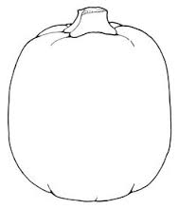
My name is _________________________. I am ________ years old.

How many pumpkins are there?

- one

- two

3 three

4 four

5 five

