Halloween
was / were / wasn’t / weren’t
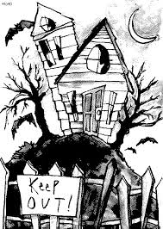  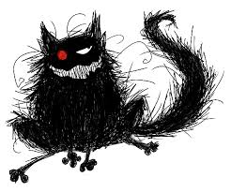 | It ………… Halloween night. It ………… dark and cold. Everybody …………… at home. But some children ……………… in the street. They …………….. excited and happy. At the end of the street there ……………. a house. It …………….. a haunted house. The children decided to go there. …………….. it a good idea?  The house …………….. very old. People ………………. too scared to go there. There ……………. so many strange stories about the place. But the kids …………. bold and brave. One boy, who …………… the leader of the group, went inside. The other kids ………….. just behind him. The house ……….. a scary place. There ………… spiderwebs everywhere. And suddenly they heard a noise. They …………… so scared they couldn’t move. One girl screamed. Something jumped at her. It …………… so dark. It …………. a big black cat. The kids ……………. bold and brave any more. They wanted to get out. It ………………… almost midnight and the house ………… suddenly full of strange noises. It ……………… a funny adventure any more.  ‘Help’, somebody shouted.

