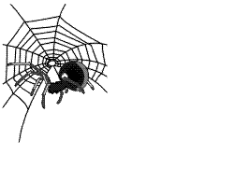
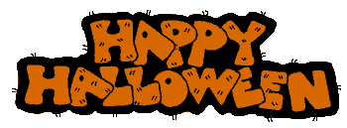
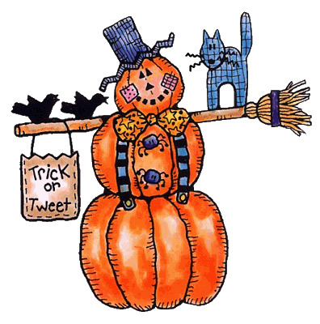

Read the following text about Halloween

Halloween is a traditional celebration held on October 31st. Today, Halloween is an excuse for Halloween theme costume parties, and entertainment with horror films, haunted houses and other activities around the popular themes of ghosts, witches, Dracula, werewolves and the supernatural. Children love to dress up in Halloween costumes and go from door-to-door in their neighborhood following the old tradition of trick-or-treating, collecting sweets and gifts, sometimes money. Originally Halloween was a pagan festival, around the idea of linking the living with the dead, when contact became possible between the spirits and the physical world, and magical things were more likely to happen. Halloween is usually celebrated by both adults and kids. Some families celebrate by having costume parties and playing special games like bobbing for apples and telling ghost stories. Sometimes children go "trick or treating" - knocking on doors in their trusted neighborhoods collecting candy. Many people also make lamps out of pumpkins. They cut faces into the side and put a candle inside, then they hang them outside their houses. People used to believe that it would scare away bad spirits and ghosts. Schools usually prefer to celebrate Halloween by having children dress as storybook characters. In this way, children are still allowed to "dress up" and the holiday becomes both fun and educational.
www.wikipedia.com

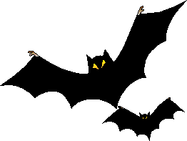

When do we celebrate Halloween?

What people usually do for Halloween?

How do the children celebrate Halloween at school?

And how people celebrate Halloween in your country?

