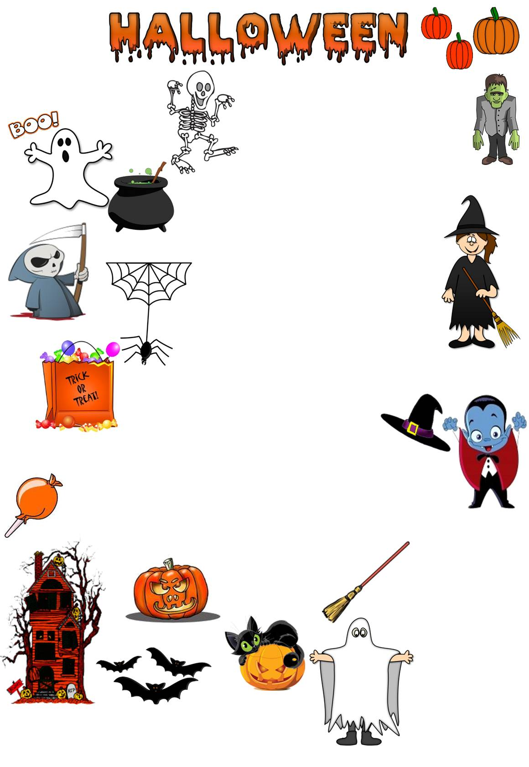
Match the words to the correct pictures and complete the crossword. Then find a secret message.

The secret message is Clothes make a statement, __________ __________ _______ __________ .

5
1
2
10
1
8
7
15
17
18
3
4
5
6
7
8
9
10
11
12
13
BATs
black cat
broom
candy
cauldron
costume
death
Dracula
FRANKENSTEIN
GHOST
HAUNTED HOUSE
JACK-O-LANTERN
PUMPKINS
SKELETON
SPIDER
TRICK OR TREAT
WITCH
WITCH HAT

14
15
16
17
18
2
3
4
6
9
11
12
13
14
16

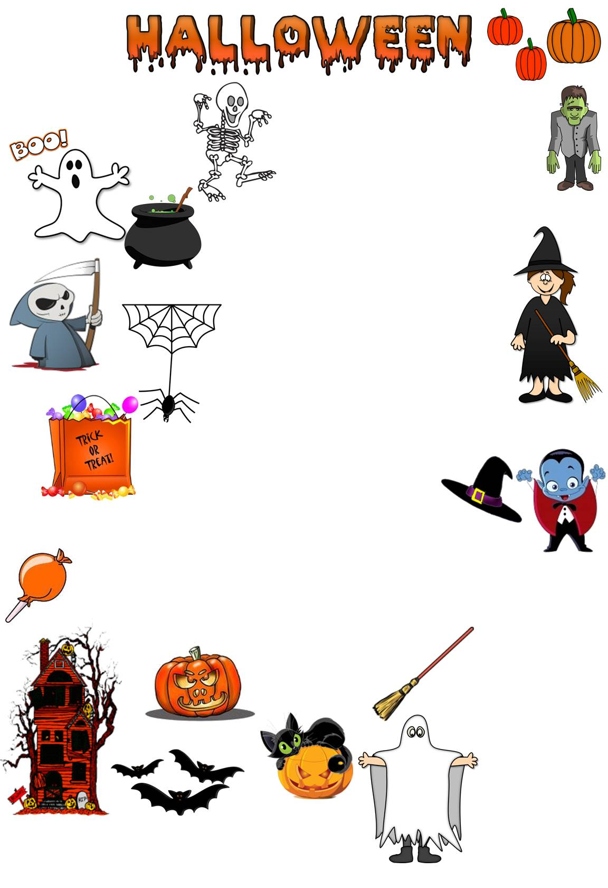
Match the words to the correct pictures and complete the crossword. Then find a secret message.

The secret message is Clothes make a statement, __________ __________ _______ __________ .

5
1
2
10
1
8
7
15
17
18
3
4
5
6
7
8
9
10
11
12
13
BATs
black cat
broom
candy
cauldron
costume
death
Dracula
FRANKENSTEIN
GHOST
HAUNTED HOUSE
JACK-O-LANTERN
PUMPKINS
SKELETON
SPIDER
TRICK OR TREAT
WITCH
WITCH HAT

14
15
16
17
18
2
3
4
6
9
11
12
13
14
16

L
K
A
S
H
Match the words to the correct pictures and complete the crossword. Then find a secret message.

I
C
H
T
E
L
N
A
D
U
H
H
U
R
R
The secret message is Clothes make a statement, costumes tell a story.

D
S
C
I
C
C
P
I
W
U
N
P
P
M
C
T
K
E
E
T
K
N
N
I
B
A
H
T
R
A
C
A
N
D
R
O
W
T
E
D
E
H
O
A
C
T
R
E
G
T
O
A
N
T
R
B
O
N
A
N
T
E
N
D
O
K
T
M
5
O
S
T
U
M
E
S
1
2
B
A
T
10
1
8
7
15
17
18
3
4
5
K
I
N
S
6
O
S
7
A
R
F
8
T
9
E
L
L
A
S
Y
R
O
T
10
11
12
D
U
C
A
13
U
BATs
black cat
broom
candy
cauldron
costume
death
Dracula
FRANKENSTEIN
GHOST
HAUNTED HOUSE
JACK-O-LANTERN
PUMPKINS
SKELETON
SPIDER
TRICK OR TREAT
WITCH
WITCH HAT

A
H
14
15
C
I
16
17
18
J
A
C
K
O
L
2
3
4
6
S
9
11
12
13
14
16
R
E
A
T

